**Group Creation:**

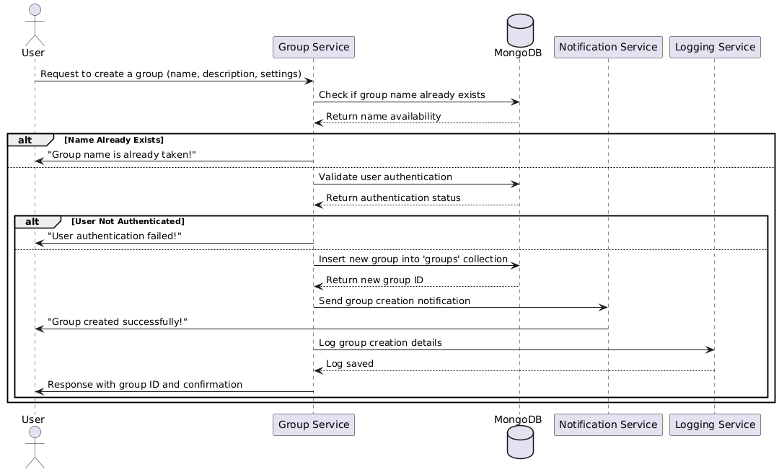

**Database:**

**Functional Requirements (FRs)**

* **FR1**: The system shall allow users to create a group by providing a name and description.
* **FR2**: The system shall validate if the group name is unique before creation.
* **FR3**: The system shall allow only authenticated users to create groups.
* **FR4**: The system shall send a confirmation notification after successful group creation.

**Non-Functional Requirements (NFRs)**

* **NFR1**: Group creation should be processed within 2 seconds.
* **NFR2**: The system shall store group data in MongoDB with proper indexing for fast retrieval.
* **NFR3**: The system shall log all group creation actions for tracking and auditing.